Stuck On Control Panel

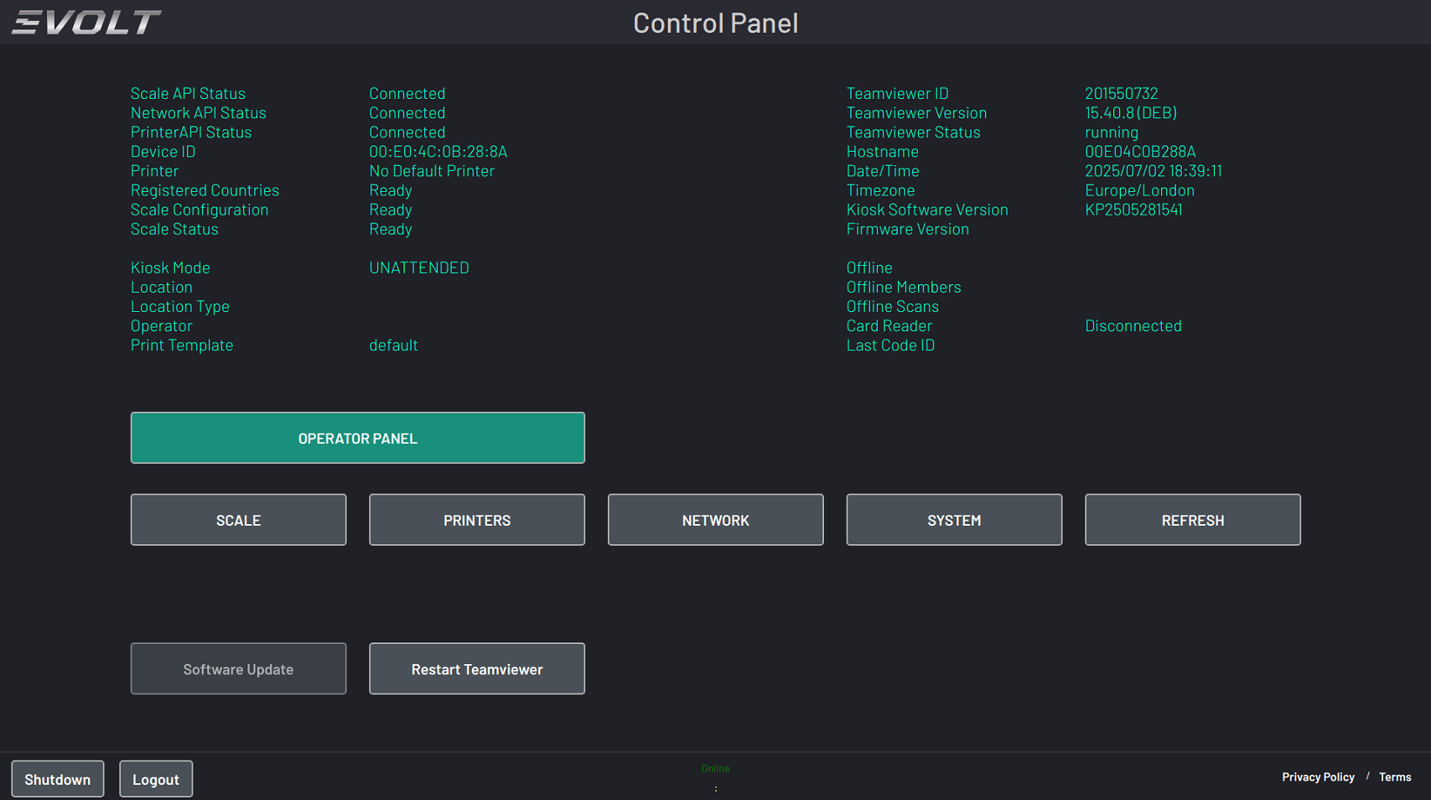

Issue
If your scanner is stuck on the Control Panel and the red Start Scanning button is missing, this typically indicates that the scanner is logged out of its Operator Panel. You can confirm this by checking the top of the screen—if the Location, Location Type, and Operator fields are blank, the scanner is not logged in.

Resolution Steps
If the Scanner is stuck on the Control Panel/ No Red Start Scanning Button; this is commonly related to the scanner being logged out of its Operator Panel; you can see above the Location/Location Type and Operator Fields are blank; indicating being logged out
Follow these steps to log the scanner back in and restore full functionality:
- Connect to the Internet
  - Ensure the scanner is connected via Wi-Fi or Ethernet.
  - If not, then press the network button and connect to a data network
- Access the Operator Panel
  - Press the Operator Panel button on the scanner interface.
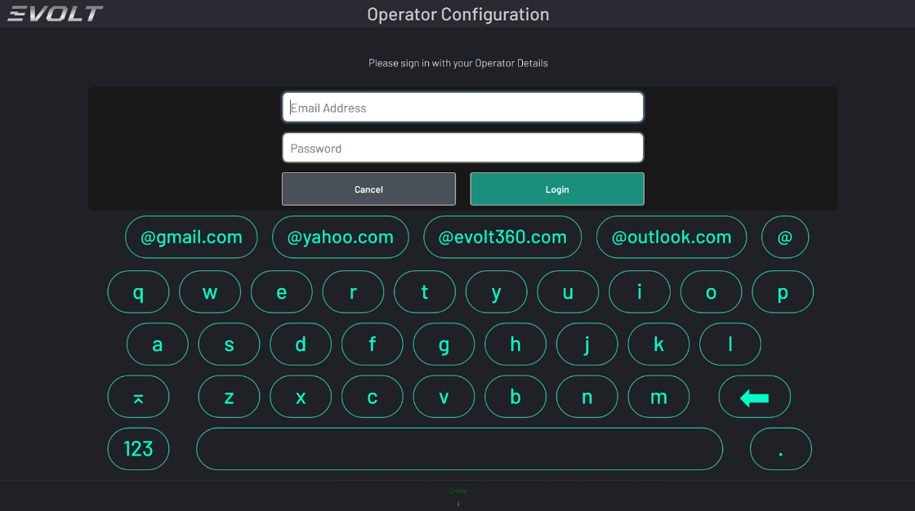

- Log In with Machine Credentials
  - Enter the credentials found in the Customer HubSpot Machine Deal. Contact the Evolt Insights Team by contacting Gelleen Bautista via teams .
  - Example credentials format:
    - Username: evoltchs@evolt360.com
    - Password: evolt01
- Configure Operator Settings
  - Select the appropriate options:
    - Location: Choose from the dropdown list.
    - Kiosk Mode: Set to UNATTENDED.
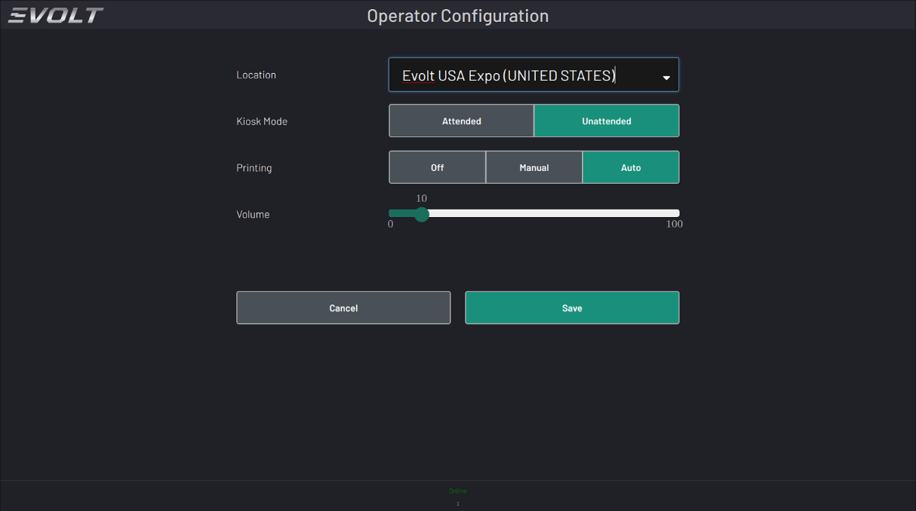
    - Print Setting and Volume: Adjust based on customer preferences.

- Save Configuration
  - Press Save to return to the Control Panel.
  - The previously blank fields for Location and Operator should now be populated.
- Refresh the Interface
  - Press Refresh to return to the Home Screen.
  - The red Start Scanning button should now be visible.
  - You should then be taken to the below screen

